Creating Avalonia project

* dotnet new avalonia.mvvm -n MyAvaloniaApp
* cd MyAvaloniaApp

Creating C# console app

* dotnet new console -n MyConsoleApp
* cd MyConsoleApp

Live charts install

* dotnet add package LiveChartsCore.SkiaSharpView.Avalonia

CSV Helper

* dotnet add package CsvHelper

Xunit

* dotnet new xunit -n MyAvaloniaApp.Tests
* dotnet sln add MyAvaloniaApp.Tests/MyAvaloniaApp.Tests.csproj
* dotnet add MyAvaloniaApp.Tests/MyAvaloniaApp.Tests.csproj reference MyAvaloniaApp/MyAvaloniaApp.csproj

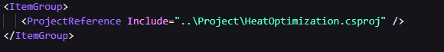

Headless

* dotnet add MyAvaloniaApp.Tests package Avalonia.Headless
* dotnet add MyAvaloniaApp.Tests package Avalonia.Controls.UnitTests

Json Helper

* Should be system included

CSV reader with different column names

